Exercise 9
UML Design using PlantUML
Aim
To design and generate a UML class diagram for an Online Shopping System using PlantUML.
Software Required
- Java JDK
- PlantUML
- Command Prompt
- Text Editor such as Notepad
Procedure
Step 1
Create a folder named PlantUML in any drive.
Step 2
Place the downloaded PlantUML .jar file in the folder.
Step 3
Open Notepad and create a new file named:
OnlineShopping.puml
While saving, select Save as type → All Files to avoid saving it as .txt.
Step 4
Enter the following PlantUML code:

@startuml

class Customer {
customerId
name
login()
placeOrder()
}

class Product {
productId
name
price
displayProduct()
}

class Cart {
cartId
addProduct()
removeProduct()
}

class Order {
orderId
orderDate
confirmOrder()
}

class Payment {
paymentId
amount
makePayment()
}

Customer --> Cart : uses
Cart --> Product : contains
Customer --> Order : places
Order --> Payment : has

@enduml
Step 5
Save the file in the same folder as the PlantUML .jar file.
Step 6
Open Command Prompt and navigate to the PlantUML folder.
Example:
F:
cd "F:\Modern Software Engineering\PlantUML"
Step 7
Execute the PlantUML program using the following command:
java -jar plantuml-1.2026.8.jar OnlineShopping.puml
Use the actual name of the downloaded JAR file if it is different.
Step 8
PlantUML processes the .puml source file and generates a UML diagram.
The output file will be:
OnlineShopping.png
Step 9
Open OnlineShopping.png and verify the UML class diagram.
Output
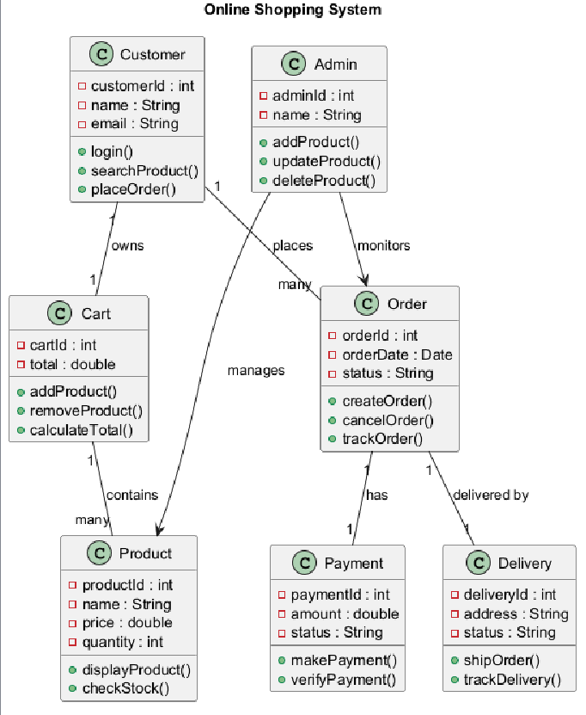

Result
Thus, a UML class diagram for the Online Shopping System was successfully designed and generated using PlantUML.

